# EEG analysis

(DESCRIBE PREPROCESSING HERE)

Group-averaged ERPs were generated for the different conditions of interest, based on the factors congruency (congruent vs. incongruent), order (positive vs. negative), and time window (very early, early, late, very late). In order to study the interactions between the factors, we also generated the averages for positive/congruent, positive/incongruent, negative/congruent and negative/incongruent trials. We performed two main analyses. The first analysis studies the effect of congruency and order, as well as their interactions, on ERP components of interest: The N1 component, analysed between 100ms and 120ms post-stimulus at Fz and Cz; the N200 component, analysed between 180ms and 220ms at Fz and Cz, and the P3a and P3b component, analysed between 310ms and 370ms at Fz and Pz, respectively.

**Statistical Analyses**

For the statistical analysis, the *rstatixs* package was used in RStudio. We conducted two main analyses using ANOVAs and post-hoc t-tests using Bonferroni correction.

Three separate analyses for ERP data:

* T-test of difference between Yes and No judgements in N200
* ANOVA with factor congruency and factor order, and their interactions
* ANOVA with factor congruency and factor temporal proximity, and their interactions

## Analysis 1: Judgements of Agency

The mean amplitudes in the N200 time window of sounds that were judged as self-generated (“Yes”) and externally generated (“No”) were compared using a paired-sample t-test. The analysis showed that the means of Yes-sounds (M = -0.415, SD = 1.723) and No-sounds (M = -2.388, SD = 2.114) were significantly different (t(25) = 5.337, p < .001).

**Figure X**

*N200 amplitudes in sounds judged as self- and externally generated*

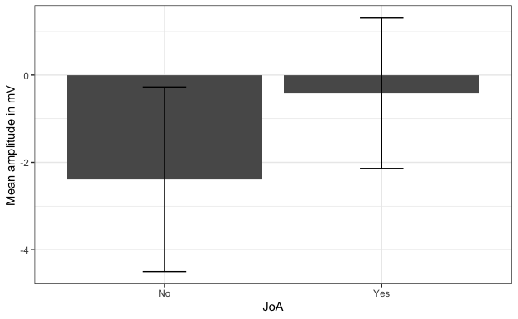

*Note: Sounds that were judged as self-generated (“Yes”) had a more positive mean amplitude in the N200 time range (180ms to 220ms post-stimulus) than sounds judged as externally generated (“No”).*

**Figure X**

*Effect of JoA on N200 amplitude in Fz and scalp distribution*

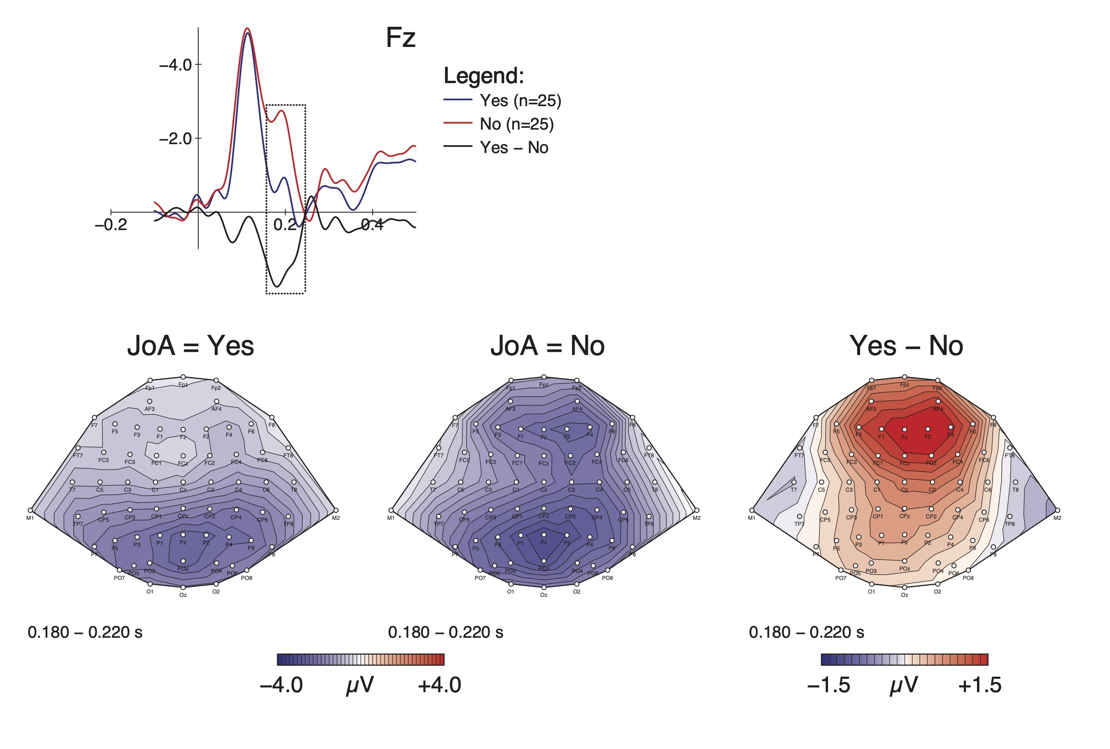

*Note: This figure shows the grand average ERPs and difference wave of sounds judged as self- (“Yes”) vs. externally generated (“No”) at the Fz electrode (top). The N200 time range is highlighted. Below, the figure shows topographical plots of the effect’s scalp distribution, with mean amplitudes across the scalp in the N200 time range.*

## Analysis 2: Congruency and order

**OVERVIEW – Tests that were performed:**

* N1 at Fz, Cz (nothing to report)
* N200 at Fz (significant effects)
* P3a at Fz (no results but reported it anyway because it seems like there is an effect in the ERPs)
* P3b at Pz (significant effects)

### N200 at Fz: Main effect of order and interaction significant

A two-way ANOVA was performed to analyze the effect of order and congruency on mean amplitude between 180ms and 220ms post-stimulus at the Fz electrode. There was a statistically significant interaction between the effects of order and congruency (F(1,25) = 9.892, p < .001). Simple main effects analysis showed that order has a statistically significant effect on mean amplitude (p < .001), while congruency does not have a statistically significant main effect (p = .071).

Post-hoc pairwise t-tests with Bonferroni correction were used to interpret the interaction. We found that all pairwise comparisons showed significant differences except the comparison of congruent (M = -2.836, SD = 2.296) and incongruent (M = -2.729, SD = 2.148) sounds in negative time windows (t(25) = -0.375, p = 1.00).

An additional ANOVA was run for the factors order and congruency in the time window of the P3a (310ms to 370ms), since visual inspection suggests that there might be an effect. However, there was no significant effect of either order (F(1,25) = 0.367, p = .550), nor congruency (F = 0.914, p = .348), nor was there a significant interaction (F = 4.181, p = .052).

**Figure X**

*ERPs showing the effect of temporal order on the Fz electrode and the topographical distribution of the effect in the N200 range*



*Note: This figure shows the ERPs for positive and negative trials as well as the difference wave. The N200 range is highlighted. Additionally, it shows the topographical distribution of the different ERPs, as well as their difference. The difference between the means in the highlighted time window is significant, while the difference visible here in the P3a range was not significant.*

**Figure X**

*Effect of congruency in positive time windows*

**

*Note: This figure shows the effect of congruency in positive trials. It gives further insight into the interaction of congruency and order. We can see that in the N200 time window (highlighted here) there is a significant difference between the means of positive/congruent and positive incongruent/trials. The difference in the N1 amplitudes visible here is not statistically significant.*

**Table X**

*Bonferroni corrected t-tests for averaged means at Fz in the N200 time window*

|  |  |  |  |  |
| --- | --- | --- | --- | --- |
| Group 1 | Group 2 | t-statistic | df | p.adj |
| neg/con | neg/inc | -0.375 | 25 | 1.00 |
| neg/con | pos/con | -9.283 | 25 | < .001 |
| neg/con | pos/inc | -6.333 | 25 | < .001 |
| neg/inc | pos/con | -7.807 | 25 | < .001 |
| neg/inc | pos/inc | -6.449 | 25 | < .001 |
| pos/con | pos/inc | 3.020 | 25 | < .001 |

*Note: This table shows the results of pairwise comparisons studying the interaction between the factors order and congruency affecting group-averaged means of the Fz amplitude in the N200 time window (180ms to 220ms post-stimulus).*

**Figure X**

*Influence of congruency and order on N200 amplitude at Fz*

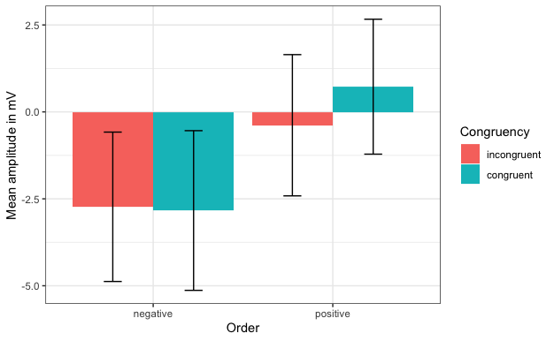

*Note: This figure shows the mean amplitude and standard deviation of all subjects in negative and positive trials divided by congruency at the Fz electrode in the time window between 180ms and 220ms.*

### P3b at Pz: Main effect of congruency and interaction significant congruent/incongruent in positive trials

A two-way ANOVA was performed to analyze the effect of order and congruency on mean amplitude between 310ms and 370ms post-stimulus at the Pz electrode. There was a statistically significant interaction between the effects of order and congruency (F(1,25) = 5.107, p = .033). Simple main effects analysis showed that congruency has a statistically significant effect on mean amplitude (F = 4.665, p = .041), while congruency does not have a statistically significant main effect (F = 0.028, p = .868).

Post-hoc pairwise t-tests using Bonferroni correction showed that there was a marginally significant difference between congruent (M = -0.264, SD = 1.360) and incongruent (M = -1.518, SD = 2.197) sounds in positive trials (t(25) = 2.722, p = .07), while no other significant differences were observed.

**Figure X**

*Influence of congruency and order on P3b amplitude at Pz*

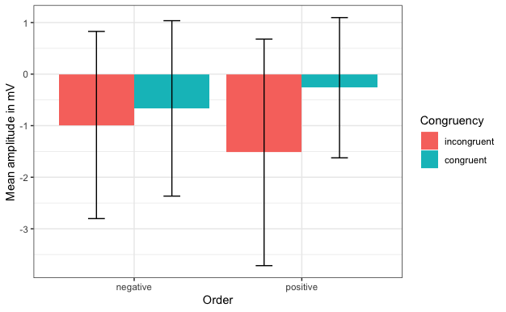

*Note: This figure shows the mean amplitude and standard deviation of all subjects in negative and positive trials divided by congruency at the Pz electrode in the time window between 310ms and 370ms.*

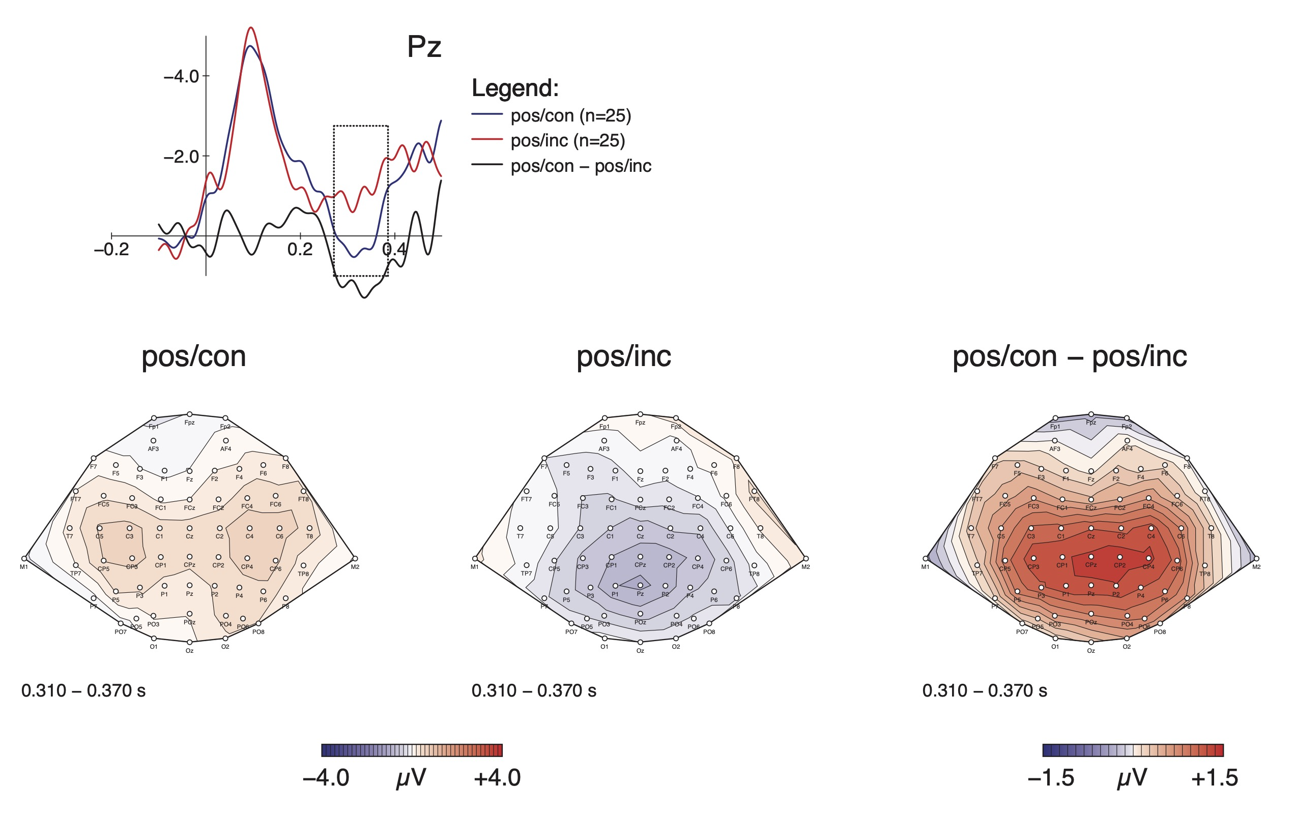

## Analysis 3: Temporal proximity

**OVERVIEW – Tests that were performed:**

* N1 at Fz, Cz (nothing to report)
* N200 at Fz
* P3a at Fz (nothing to report)
* P3b at Pz

### N200 at Fz: N200 amplitude depends on temporal proximity

A one-way ANOVA was performed to analyze the effect of temporal proximity between BP and sound on mean amplitude between 180ms and 220ms post-stimulus at the Fz electrode. Simple main effects analysis showed that temporal proximity has a statistically significant effect on mean amplitude (F(3,75) = 28.697, p < .001), while congruency does not have a statistically significant main effect (F = 0.028, p = .868).

Post-hoc t-tests with Bonferroni corrections showed that the difference between TW1 (M = -3.236, SD = 2.381) and TW2 (M = -2.069, SD = 2.230) is not significant (t(25) = -2.415, p = .140), the difference between TW2 and TW3 (M = -0.315, SD = 1.741) is significant (t = -5.180, p < .001), and the difference between TW3 and TW4 (M = 0.951, SD = 2.121) is not significant (t = -2.705, p = .073).

**Figure X**

*Amplitude of N200 depends on temporal proximity between BP and sound*

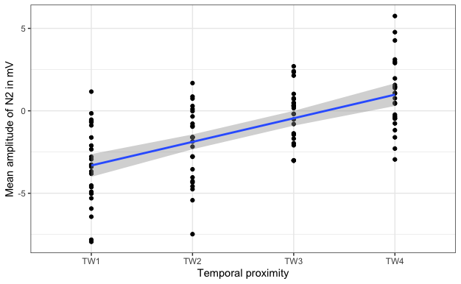

*Note: This plot shows the mean amplitude of the N200 across subjects and different time windows. A linear regression is fitted to the data.*

**Figure X**

*ERPs of different time windows at Fz electrode and scalp distributions in the N200 range*

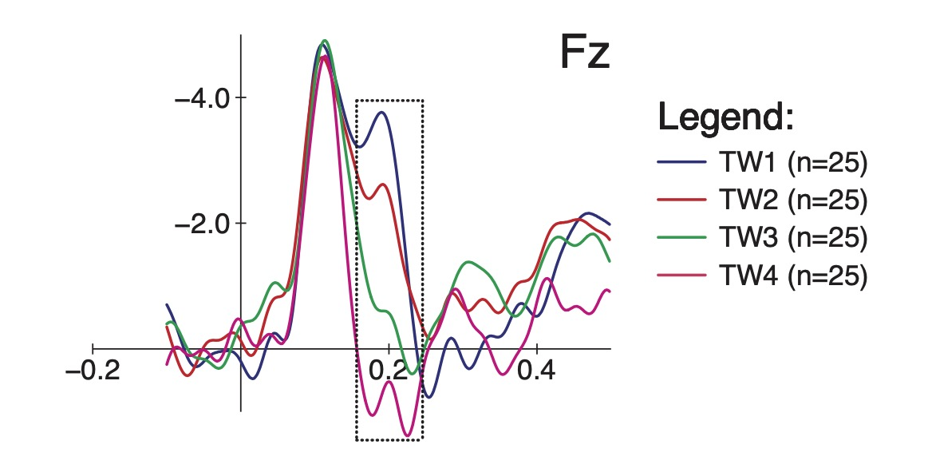

**

*Note: This figure shows (at the top) the ERPs of the different levels of the factor temporal proximity at the Fz electrode. The temporal range of the N200 is highlighted. Further down, it shows the scalp distributions in the different conditions and the differences between TW1 and TW2, and between TW3 and TW4, respectively.*

**Table X**

*Post-hoc tests studying the effect of temporal proximity on N200 amplitudes at Fz*

|  |  |  |  |  |
| --- | --- | --- | --- | --- |
| Group 1 | Group 2 | t-statistic | df | adj.p |
| TW1 | TW2 | -2.415 | 25 | .140 |
| TW1 | TW3 | -6.141 | 25 | < .001 |
| TW1 | TW4 | -6.953 | 25 | < .001 |
| TW2 | TW3 | -5.180 | 25 | < .001 |
| TW2 | TW4 | -5.700 | 25 | < .001 |
| TW3 | TW4 | -2.705 | 25 | .073 |

*Note: This table shows the adjusted p-values, degrees of freedom and t-statistic for comparisons between different levels of the factor temporal proximity. The difference between TW1 and TW2, as well as the difference between T 3 and TW4, were not significant. All other comparisons were significantly different, including the adjacent time windows TW2 and TW3.*

**Figure X**

*Effect of temporal proximity between BP and sound on N200 amplitudes at Fz*

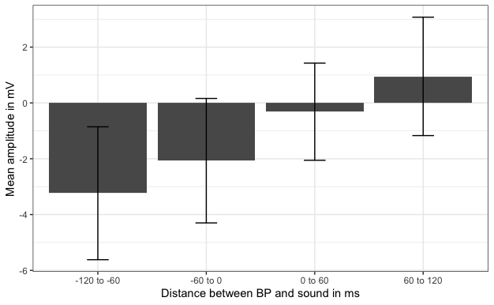

*Note: The amplitude of the N200, here measured between 180ms and 220ms post-stimulus, varies with the relative timing of BP and sound. The smallest N200 is elicited by sounds presented between 0ms and 60ms after the BP.*

### P3b at Pz: Very early sounds elicit a P3b response

A one-way repeated-measures ANOVA was run for the four-level factor temporal proximity at the Pz electrode in the time range of the P3b component (310ms to 370ms post-stimulus). A statistically significant main effect was found (F(3,75) = 3.455, p = 0.020).

Pairwise post-hoc t-tests were performed in order to compare the groups. After Bonferroni correction, none of the comparisons was significant. However, the difference between TW1 and TW2 was significant before adjustment for multiple comparisons (t(25) = 2.715, p = .012), but after adjustment the p-value was raised beyond the alpha level of .05 (p = .071).

**Table X**

*Comparisons between different time windows at Pz in P3b range using post-hoc t-tests*

|  |  |  |  |  |  |
| --- | --- | --- | --- | --- | --- |
| Group1 | Group2 | t-statistic | df | p | adj.p |
| TW1 | TW2 | 2.715 | 25 | 0.012 | 0.071 |
| TW1 | TW3 | 2.081 | 25 | 0.048 | 0.287 |
| TW1 | TW4 | 0.771 | 25 | 0.448 | 1.000 |
| TW2 | TW3 | -0.168 | 25 | 0.867 | 1.000 |
| TW2 | TW4 | -2.132 | 25 | 0.043 | 0.258 |
| TW3 | TW4 | -2.269 | 25 | 0.032 | 0.193 |

*Note: Post-hoc t-tests between the different time windows showed that after Bonferroni correction for multiple comparisons, none of the differences was statistically significant. However, the difference between TW1 and TW2 was significant before correction, and remained marginally significant after.*

**Figure X**

*ERPs of different time windows at Pz electrode and scalp distribution*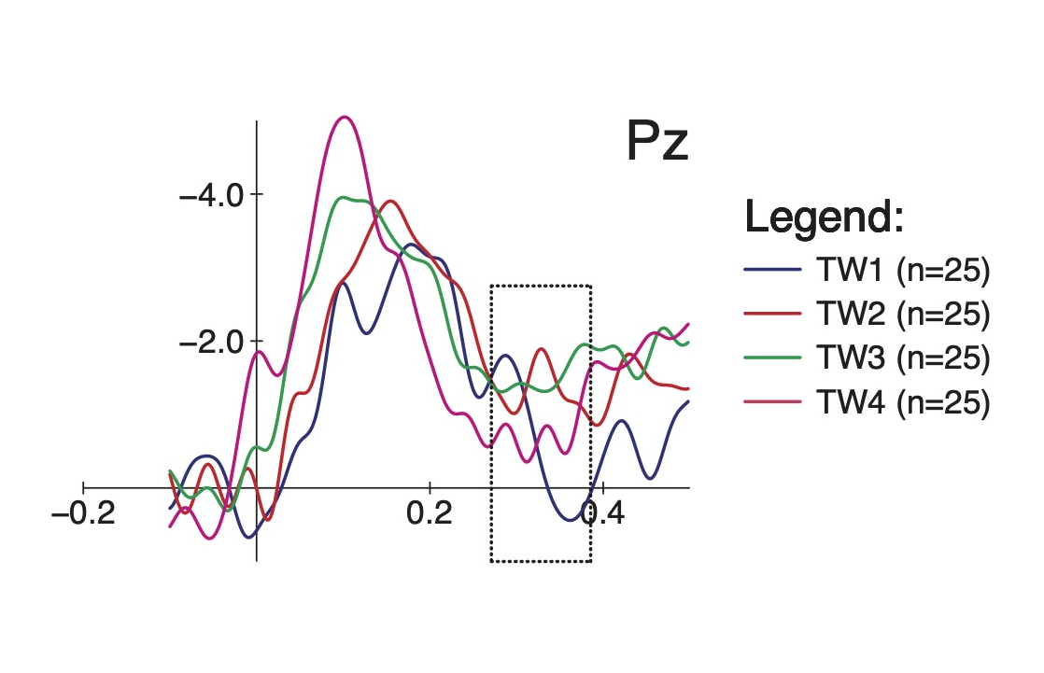  
**

*Note: At the top, we see ERPs of the four different time windows at the Pz electrode. The time range of the P3 is highlighted. The figure shows that very early sounds trigger a P3b response. At the bottom, scalp distributions of TW1 and TW4, as well as the difference between them, are shown for the P3 range (310ms to 370ms).*

**Figure X**

*Effect of temporal proximity on P3b amplitude in Pz*

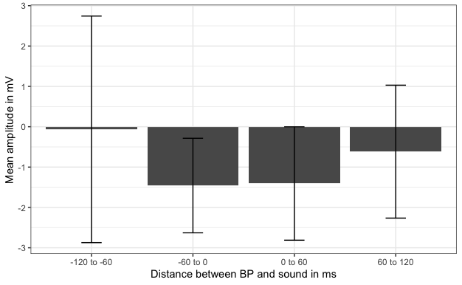

*Note: This figure shows the amplitudes of the P3b (defined as between 310ms and 370ms) in four different time windows. Sounds that are played close to the BP (either right before or right after) elicit similar responses.*

## SUMMARY OF FINDINGS

* Sounds judged as externally generated trigger an N200
* Mysterious parietal N1 effect visible in Yes vs. No sounds and posinc vs. neginc
* Main effect of order on N200: Negative sounds trigger N200
* Interaction of congruency and order in N200: In positive/congruent trials, N200 disappears
* Main effect of congruency on P3b: Congruent sounds trigger P3b, especially visible in positive trials
* Main effect of temporal proximity on N200: N200 diminishes with time window progression
* Main effect of temporal proximity on P3b: Very early sounds trigger P3b
* Extra stuff in cluster-based comparisons:
  + Poscon/negcon P3?
  + TW2 vs TW3 N1 difference parietal
  + Yes vs. No P3 effect

Alternative way to structure the results:

**N1 effects:**

* Yes/No parietal: attenuation of parietal N1 for No-sounds, peak delayed
* TW2/TW3 same as above
* PosInc/NegInc: huge parietal differences in N1, both amplitude and latency; amplitude difference in N1 also in frontal electrodes (positive sounds attenuated)

**N2 effects:**

* Pos/Neg
* PosCon/NegCon
* PosInc/NegInc
* TW2/TW3
* TW3/TW4
* Yes/No

All these seem to be the same phenomenon, which is that order has a strong influence on N2, regardless of congruency. What is interesting is that the effect is sensitive to temporal proximity, diminishing gradually.

**P3 effects:**

* Yes/No: central location, stronger positive for Yes-sounds
* Con/Inc: central/parietal location, stronger P3 for congruent sounds
* NegCon/NegInc: parietal location, stronger P3 for congruent sounds in negative order
* PosCon/NegCon: central location, stronger P3 for PosCon than NegCon
* TW1/TW2: stronger P3 for TW1 in parietal region
* TW3/TW4: stronger P3 for TW4, fronto-central